Submitted to: Sir Qaiser
Submitted By: Talha Kayani
Roll No: 2530366
Department: BS CYS(B)
Course: OOP LAB

Assignment

Question No 1 Output:

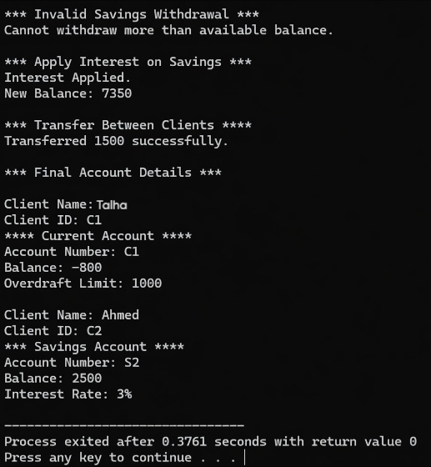

Question No 2 Output:
